Virada Games Application User Manual

30003389 – Kyer Potts

Table of Contents

Getting Started 2

Creating a Product 2

Creating a Customer 3

Creating a Transaction 4

# Getting Started

When the application loads for the first time, no save data will be present. When the user closes the application for the first time, the program will automatically generate save files of all data entered into the application. Data will then be loaded automatically whenever the program is opened from that point on.

# Creating a Product

To create a Product, enter all the necessary fields relating to the product. All fields in the Item Info section will need to be populated, however the Games, Platforms and Accessories fields will need to be populated independently of each other depending on the type of product you are trying to enter.

Ensure that all required fields are populated correctly to record the data

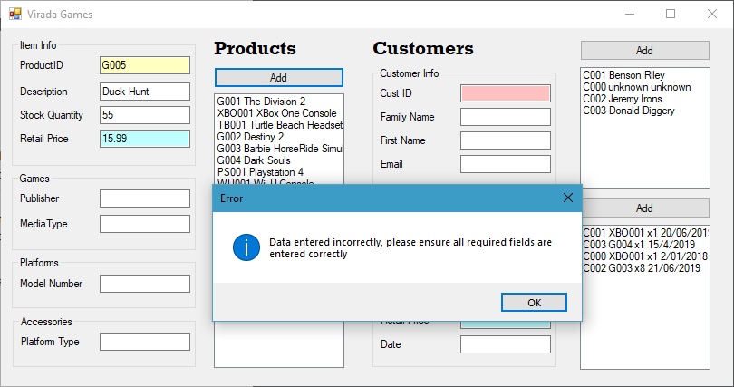

# Creating a Customer

To create a Customer entry, ensure that all customer fields are populated with the correct information. If a field is left blank and you click the add button, an option to create a DEFAULT user will become available. Click Yes to create a DEFAULT user.

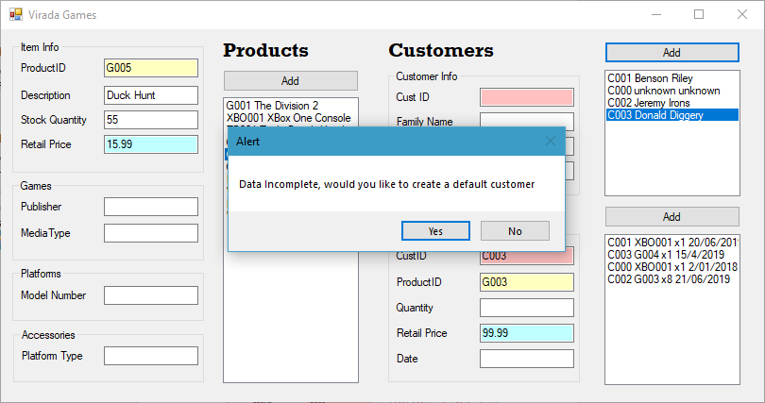

# Creating a Transaction

To create a transaction, the Products and Customers lists must have information entered into them. Once that information has been entered, the user can select the relevant items from the Products and Customers lists, which will then populate the READ ONLY fields within the Transactions section. The READ ONLY fields are colour coded appropriate to the respective Products and Customers fields that information is retrieved from.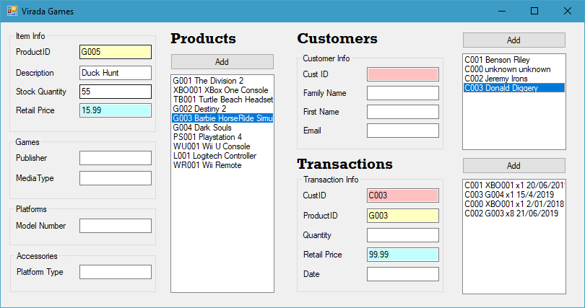

Once the READ only boxes have been populated correctly, enter the quantity and date and click Add.

To retrieve Product and Customer information from a recorded Transaction, simply select the relevant transaction from the list, and the Product and Customer list and fields will be populated automatically with the relevant information.

